CS 11A: Technology & Computing Components I
HOS01A: Cloud Development Environment

Reviewed by Vishal Krishna Kumar on 03/19/2026
Reviewed by Sumit K C on 06/11/2026
Reviewed by Clark Ngo on 08/11/2026

School of Technology and Computing (STC) @City University of Seattle (CityU)

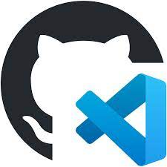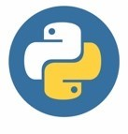

Before You Start
- Screenshots may be different from your environment. Use your best judgement to complete the assignments.
- All the steps and concepts in this tutorial are from references, so if you encounter problems, please try to read and compare the references to solve the problem. If you still can't solve the problem, please get in touch with your course Student Worker – Teaching Assistant.
- While we try to explain each step with the appropriate amount of detail. If you are not sure what to do:
  - Consult the resources for the course including the tools within GitHub Codespaces such as CoPilot chat.
  - If you cannot solve the problem after a few tries (usually 15 -30 minutes), ask a Student Assistant for help.

Learning Outcomes
- Section 1: What is Git and GitHub
- Section 2: Pushing your first assignment to GitHub

Section 1: What is Git and GitHub
- Git: This is the industry standard version control software. Think of it as a powerful "undo" button and a way for large teams of developers to keep their work synchronized. You'll use it to manage and submit your code.
- GitHub: This is a website that hosts projects using Git, allowing for collaboration. We use GitHub Classroom, a special feature of GitHub, to distribute and collect your assignments.
- GitHub Codespaces: This is a cloud-based development environment where you will write, run, and complete your programming assignments. It ensures that everyone in the class has a consistent, ready-to-use workspace!
Accessing GitHub Codespaces: GitHub Codespaces are online, cloud-based development environments that allow you to quickly write, run, and debug your code. They are fully integrated with your GitHub repository and provide seamless experience for developers.

- In the top-right corner, click on the “<>Code” drop-down menu. Select "Create codespace on main."

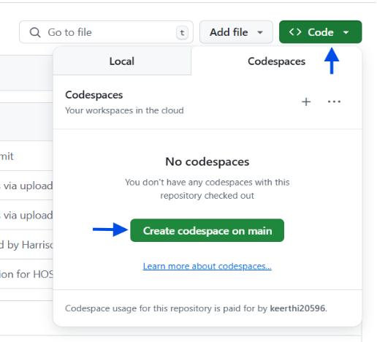

- If you close your codespace and need to reopen it, make sure to click on the one you already created. Don’t open a new codespace, as it won’t include the setup you configured in the original one.
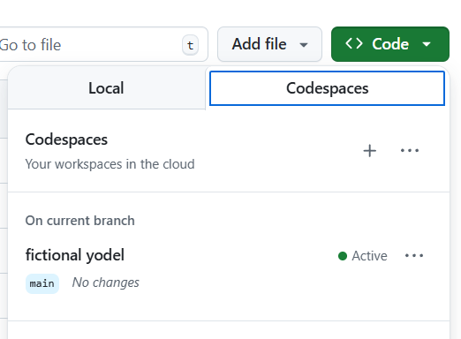

- Wait for the GitHub Codespaces environment to load. Once loaded, you can access the terminal, File Explorer, and other tools to start working on your project. Your screen should look like the screenshot below. You can pick a theme that you like.
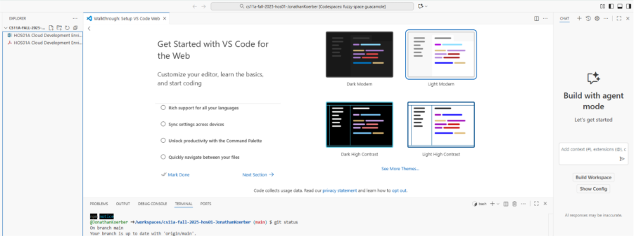

- Now we can see the major components that we are working with. GitHub Codespaces is a text edit for code files. In the left window, we can see that we have access to the file explorer showing the files that we have in the repository. The main window is where we edit files. In the Right-hand side of the page, we have a Copilot agent. Below the main window, you can see the terminal which allows us to interact with the environment.


- Next let’s look in the far-left gutter here we can see icons that control what is displayed in the left window. From top to bottom File Explorer, Search, Source Control (Git History), Run in debug mode, Extensions, AI Agent Sessions. We will cover this as needed. One command that is very useful is the keyboard cut that is worth remembering is Ctrl + Shift + P (Command + Shift + P for MacOS users). This opens the Command Prompt. From the command prompt, you can search for the environment. In the case below I searched “new term”, and the top choice is Create New Terminal which I can click on to create a new terminal, or I can use the provided keyboard shortcut. Then click on the bash.

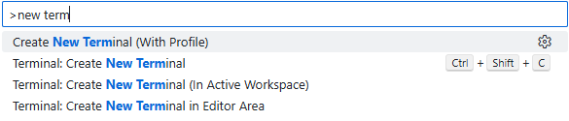

- Next, we are going to create a new file called README.md. This is a file that is used in projects to explain what you are working on. The file ending “md” means that we will use a markdown which is a very light weight language for us to format text. Write the command into your terminal window and type. touch README.md

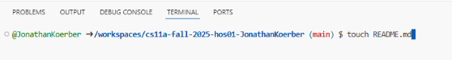

- We’ll create some text for this file but first learn a little about the command we just ran. Press the keyboard shortcut for the Command Prompt (Ctrl + Shift + P). In the command prompt, type Chat: Explain Last Command. This will open the Copilot chat window and give us an explanation about the command that we just ran.

What we have here is an AI tool built into the GitHub Codespaces. This is a powerful way that we can include AI in our learning process. Engaging with the AI agent can be a tool that can help us understand new concepts. There is a risk of exploiting the technologies that can undermine the goal of the course is for you to get a good base of programing knowledge.

- Next, let's look at what this can look like in practice. Earlier, we created a README.md file. Let's get started with a short write up of what this repo will look like. Go to the chat box and ask, “Create a markdown guide in the README.md file that was just created” This should be enough information about how to format text in Markdown. Open the README.md file that you created. Next, click the icon to open a preview of the file.

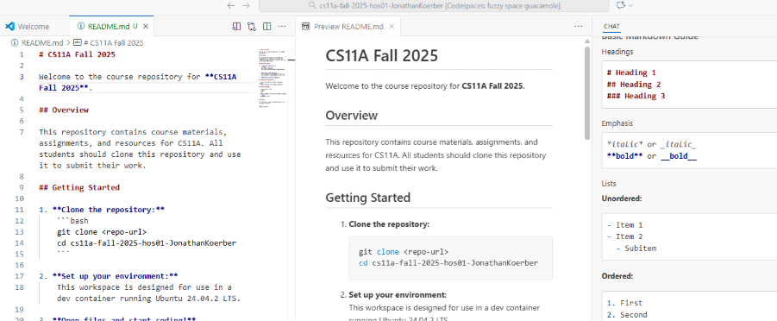

- Next, let's create a Python file. Go to the terminal, like when we create the README file, we will type touch HelloPython.py. This will create a new file that we can write in Python code.

- Open our HelloPython.py. Now we can look at the code generation feature of Copilot. Press Ctrl + i (or Command. + i for MacOS). This will launch a prompt that you can ask for code. You can change the prompt if you would like it to read something like “I have never written code before please show me some basic python. Explain everything”. Then you can click Accept. You may need to click the add icon shown below. Look at the code to see if there is anything that you don’t understand and use the Copilot agent to clear up any questions.

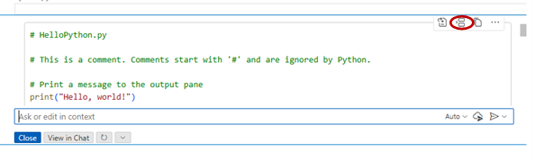

- Next, Run the file by running the command python3 HelloPython.py. You should see the output of the file in the terminal. In this command python3 is the command that we are calling, and we are passing an argument, in the case the file name HelloPython.py, for it to execute. Depending on what code is generated, your output will vary.

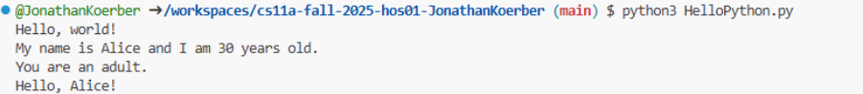

Section 2: Pushing your first assignment to GitHub

  - When you’re finished using Copilot, On the left gutter, you can see the Extensions panel , click on it and search for Copilot. Select the Copilot extension and click Disable. This will prevent Copilot from generating code suggestions automatically, allowing you to focus on learning. You can enable the extension anytime you want to use Copilot again.

If you have an active subscription, GitHub Copilot is enabled by default.

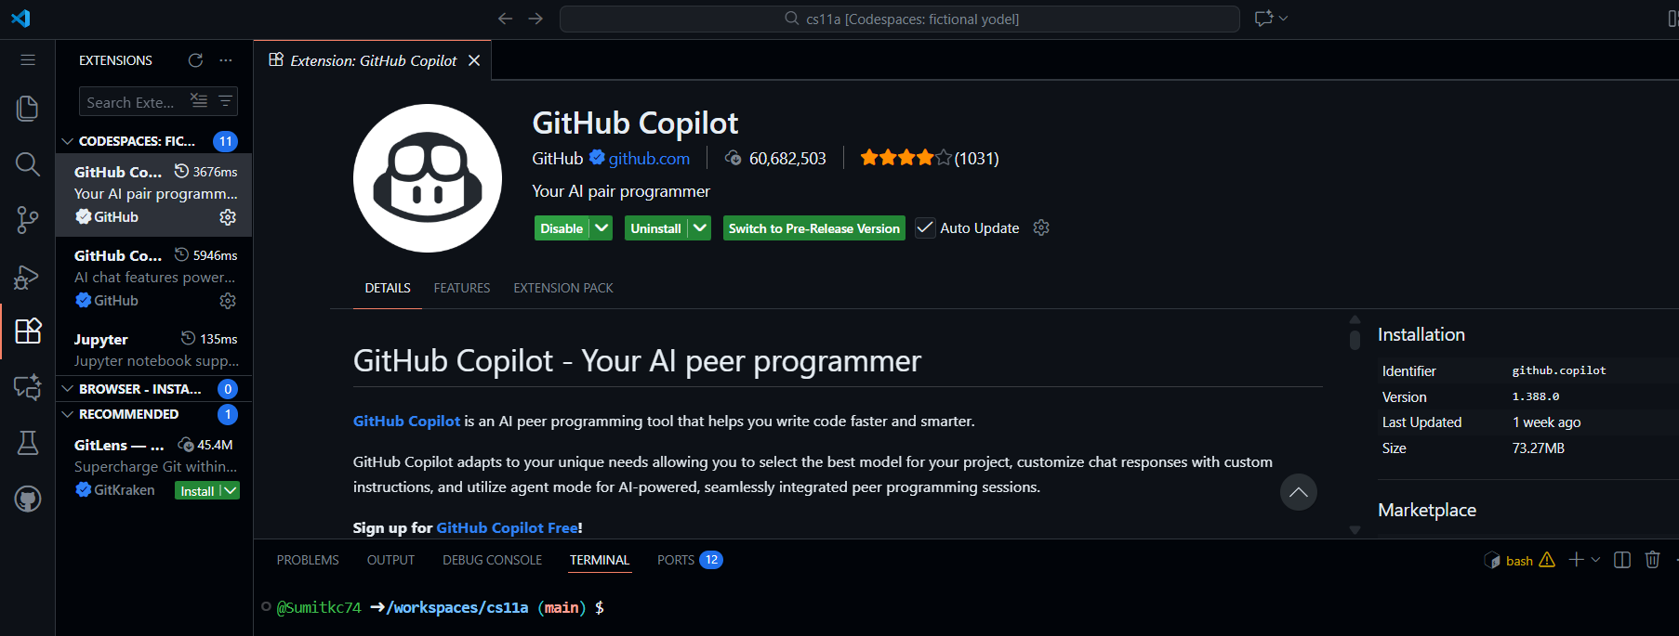

  - Next, we need to add these files that we created to our repository. On the left gutter you can see a squiggly line with a blue circle with a number inside . Click this. The Sources Control GUI will pop out. Next, we need to add to our changes. On the right side of the Source Control GUI, you may have to hover to see the plus simple as shown below. Click it to add changes. This will add to all the changes we have made. Add a brief message that describes what we have done in the message input field above the commit button. Then, press Commit.

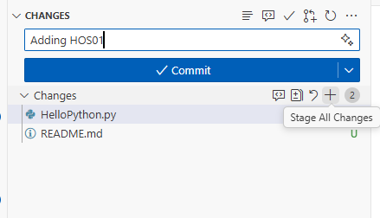
Add Changes

  - Then press Sync Changes. This will make the changes from GitHub Codespaces and sync (move) then with your original repository. GitHub Codespaces is a cloud computing resource which is a fancy way of saying that you are using someone else's computer when you are using GitHub Codespaces. This is why you need to sync changes.

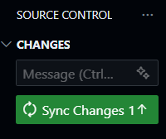

  - Double check that your changes are in your original repository. Go to the tab that you launched your codespace from. You will need to refresh your browser, then you will be able to view the changes that you created.

Nice work! you created your first codespace. You used AI to learn a thing or two about markdown and added READEME.md file with a summary of what you are doing and playing around with Python.

Assignment Recap
We took a tour through GitHub Codespaces environment. We created files using BASH terminal commands. Then, we wrote some Python code using an AI agent. Finally, we committed our changes to GitHub.

